Q#1

You have given two lists. Write a Python program to convert them into a dictionary in a way that item from list1 is the key and item from list2 is the value.

List1_keys=[“a”,”b”,”c”,”d”,”e”]

List_values=[1,2,3,4,5]

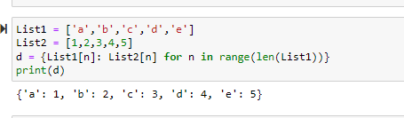

Q#2

Write a program that lets the user enter some English text, then converts the text to

Pig-Latin. To review, Pig-Latin takes the first letter of a word, puts it at the end, and

appends “ay”. The only exception is if the first letter is a vowel, in which case we

keep it as it is and append “hay” to the end. For example: “hello” -> “ellohay”, and

“image” -> “imagehay”

It will be useful to define a list or tuple at the top called VOWELS. This way, you can

check if a letter x is a vowel with the expression x in VOWELS.

It’s tricky for us to deal with punctuation and numbers with what we know so far, so

instead, ask the user to enter only words and spaces. You can convert their input from

a string to a list of strings by calling split on the string:

“My name is qazi waqas”.split(“ ”) -> [“My”, “name”, “is”, “qazi”, “waqas”]

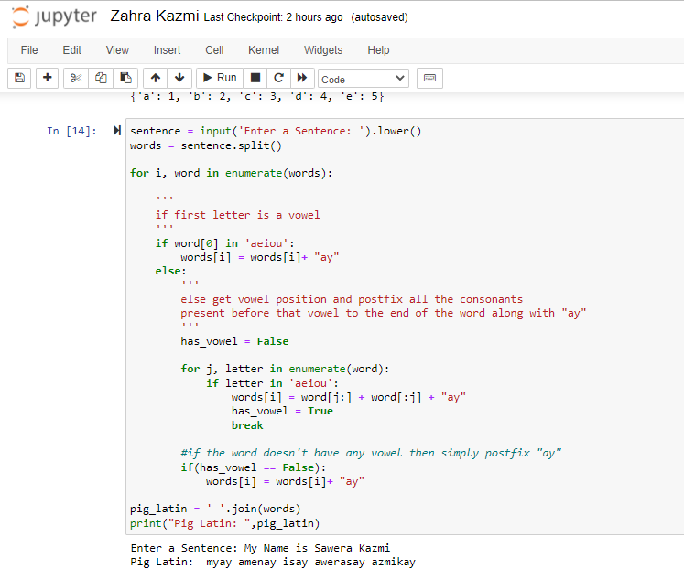

Question #3:

Write a program that calculates the user’s body mass index (BMI) and categorizes it asunderweight, normal, overweight, or obese, based on the table from the United States Centers for DiseaseControl.

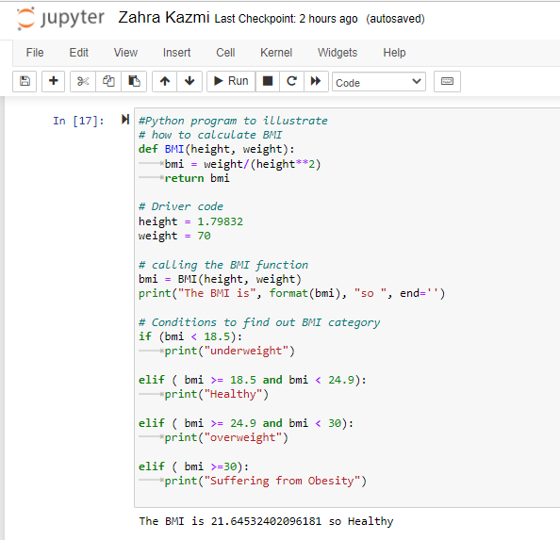

Question #4:

Write a program that needs to ask the user for her or his email address in the format firstname.lastname@cuiatk.edu.pk OR firstname.lastname@gmail.com. The application takes as input this email address, parses the email and replies to the user with first name, last name and host name.

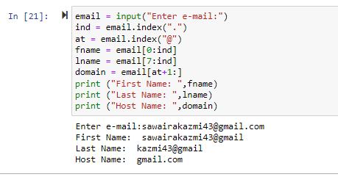

Question #5:

Write a program to count the numbers of characters in the string and store them in a dictionary data structure.

String1=”The CUI was established in 1998, as a project of the Commission on Science and Technology for Sustainable Development in the South”

